BANDIT GAME

Written in order of:

username password (the challenge in the respective level [for password for the next level])

level 0 password= bandit0 bandit0 (connecting using ssh command w -l for user and -p for port )

1:bandit1 ZjLjTmM6FvvyRnrb2rfNWOZOTa6ip5If ( dashed functions need to have their location specified,[ ./- which refers to its location])

2:bandit2 263JGJPfgU6LtdEvgfWU1XP5yac29mFx ( spaces in the name of the file, similar to the previous question , here put '' quotations for the file name so that you can fit it in as a strings cause there are spaces)

3:bandit3 MNk8KNH3Usiio41PRUEoDFPqfxLPlSmx(same thing as before, but its a hidden file)

4:bandit4 2WmrDFRmJIq3IPxneAaMGhap0pFhF3NJ(same thing as before , jus that console gets messed up so use reset or ctrl+l, and you gotta find the file (file07)), alternate solution would be using "file ./*" to find the type of all the files to find out which is the ASCII text, then you can choose it w/o wasting time on trial and error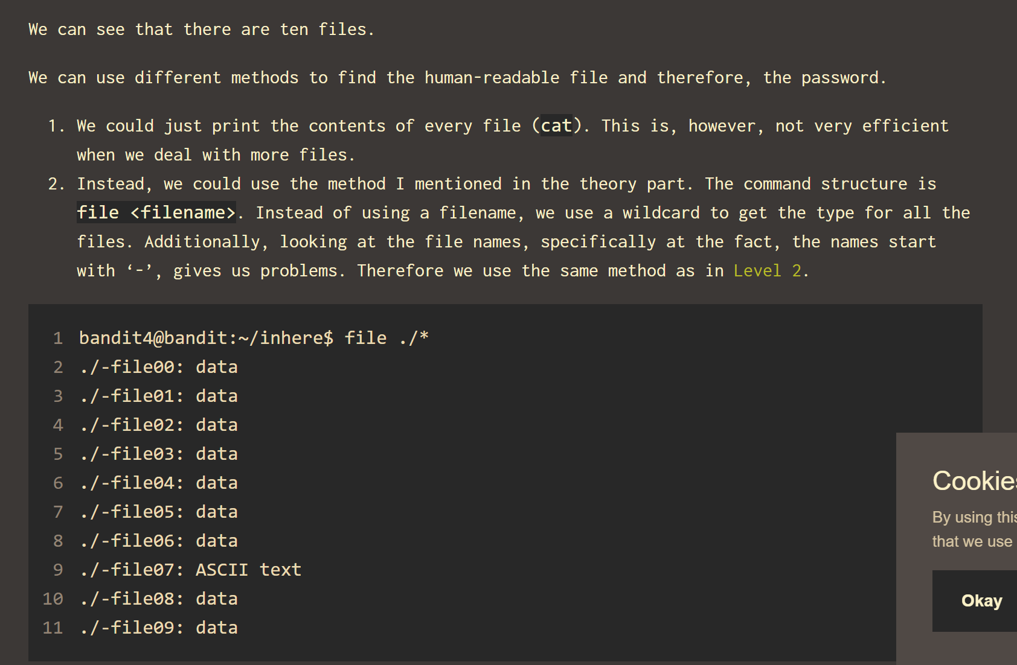

5:bandit5 4oQYVPkxZOOEOO5pTW81FB8j8lxXGUQw (what I did was du -ab , which shows all the directories and files inside the respective directories and their sizes, there weren’t much and all the sizes were diff eventually I came across one w 1033 bytes size , and when I checked it up it was an ascii text so locked on it) ,alternate soln: do the below soln, simpler

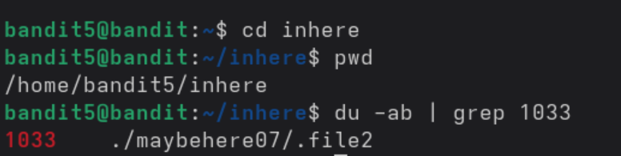

6:bandit6 HWasnPhtq9AVKe0dmk45nxy20cvUa6EG

(used the find command to find the files which bandit6 has access to and used the pipe to then use grep to find password) 

**2>/dev/null** is important as it prevents the annoying permission denied thing

What this does is that this 2 is denoting stderr (standard error) like 0 is std in , 1 is stdout, 2 is stderr what 2> does is it redirects to whatever you give and is /dev/null which is like a black hole, its used to hide unwanted output

find / searches from root directory , -type f for checking only files , -group to put group (bandit6), if you put in -user bandit7 too itll satisfy the questions conditions

7: bandit7 morbNTDkSW6jIlUc0ymOdMaLnOlFVAaj (easiest one so far jus use grep millionth data.txt)

8: bandit8 dfwvzFQi4mU0wfNbFOe9RoWskMLg7eEc